ASSINGMENT 3.3
PINDI SHARANYA REDDY
2303A52333
BATCH 42

TASK 1
AI-Generated Logic for Reading Consumer Details
PROMPT
Generate a Python program for an electricity billing system that reads previous units, current units, and type of customer from the user. Calculate the units consumed by subtracting previous units from current units. Implement all logic directly in the main program without using any functions and display the output clearly

CODE
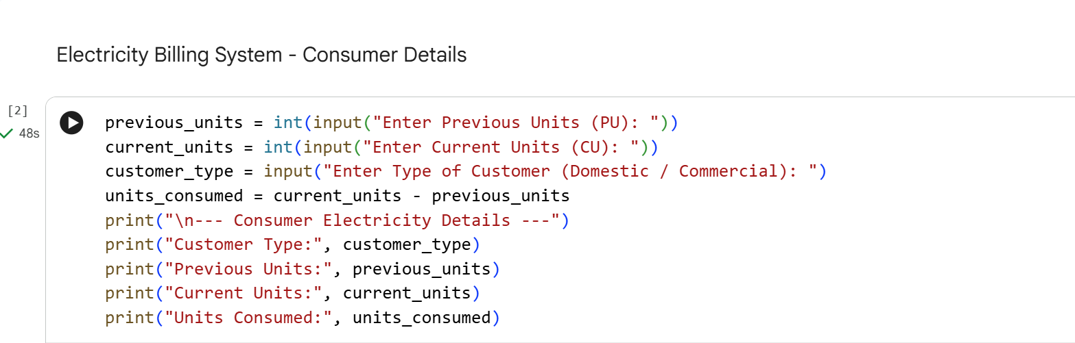
OUTPUT
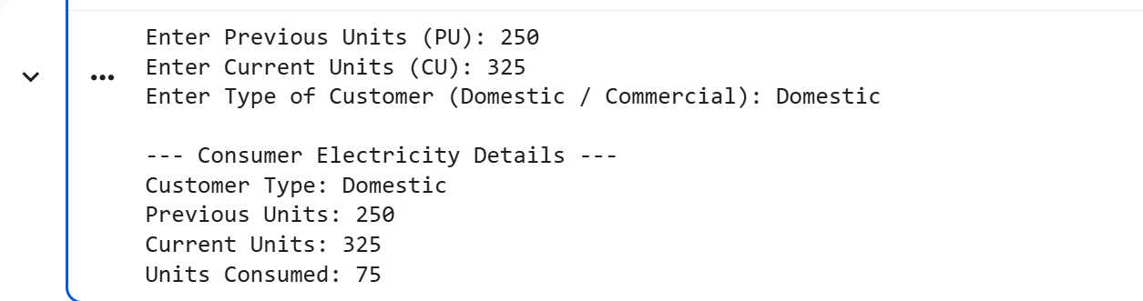
JUSTIFICATION
This program accurately collects consumer details and calculates electricity units consumed using simple input and arithmetic operations. The logic is implemented directly in the main program without functions, fulfilling the given constraints. AI assistance helped generate clear, structured, and error-free code efficiently. The approach improves productivity while maintaining correctness and readability.

TASK 2
Energy Charges Calculation Based on Units Consumed
PROMPT
Extend the electricity billing Python program to calculate energy charges based on units consumed and customer type such as Domestic, Commercial, and Industrial using conditional statements. Do not use functions.
CODE
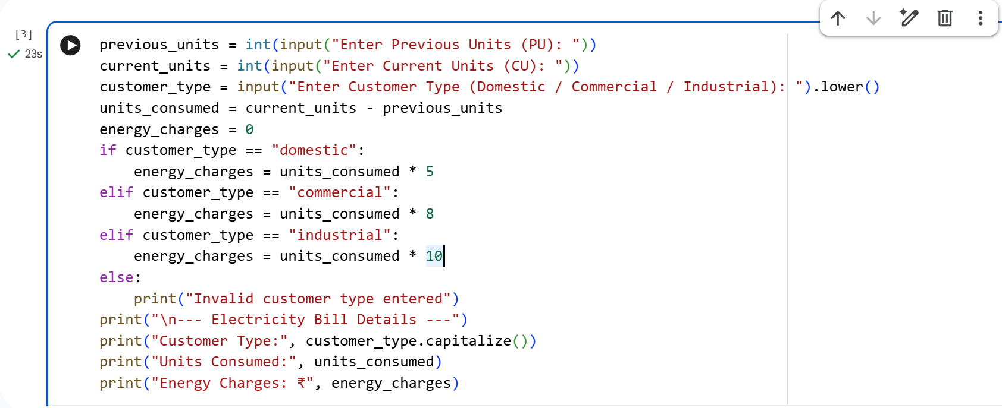
OUTPUT
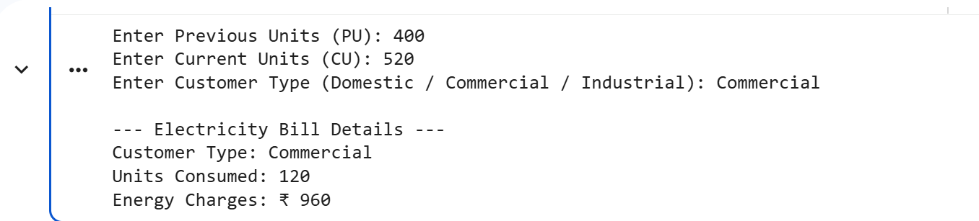
JUSTIFICATION
The program accurately calculates energy charges based on units consumed and customer type using clear conditional statements. AI assistance helped simplify and optimize the billing logic, improving readability and reducing complexity. The use of structured if-elif-else conditions ensures correct charge calculation for domestic, commercial, and industrial consumers. This approach makes the code easy to understand and maintain.

TASK 3
Modular Design Using AI Assistance (Using Functions)
PROMPT
Generate a Python electricity billing program using user-defined functions. One function should calculate energy charges based on units consumed and customer type, and another function should calculate fixed charges. Functions must return values and include meaningful comments.
CODE
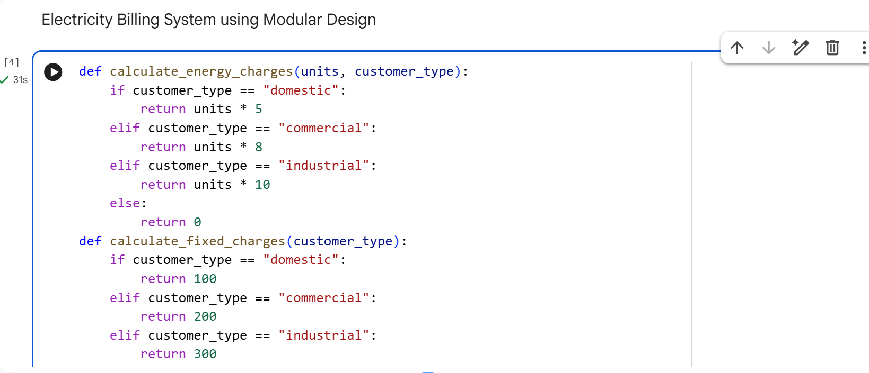
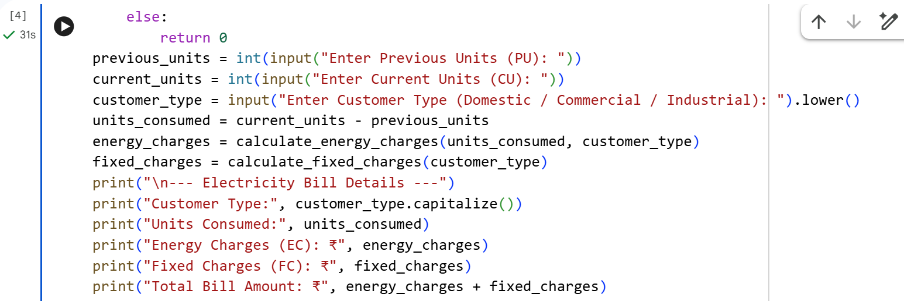
OUTPUT
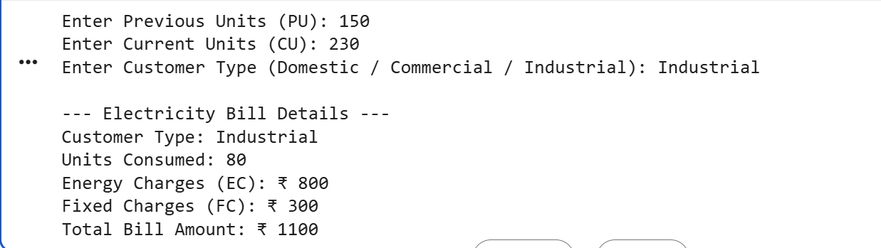
JUSTIFICATION
This program uses a modular design by separating billing logic into user-defined functions, making the code reusable and easy to maintain. AI assistance helped in structuring clear functions with meaningful comments and return values. The approach improves readability and allows efficient billing for multiple consumers. Modular design also simplifies future enhancements and testing.

TASK 4
Calculation of Additional Charges
PROMPT
Extend the electricity billing Python program to calculate additional charges including Fixed Charges (FC), Customer Charges (CC), and Electricity Duty (ED) as a percentage of Energy Charges. Ensure individual charge values are printed clearly, intermediate results are correct, and the final output is well-structured to improve billing accuracy.
CODE
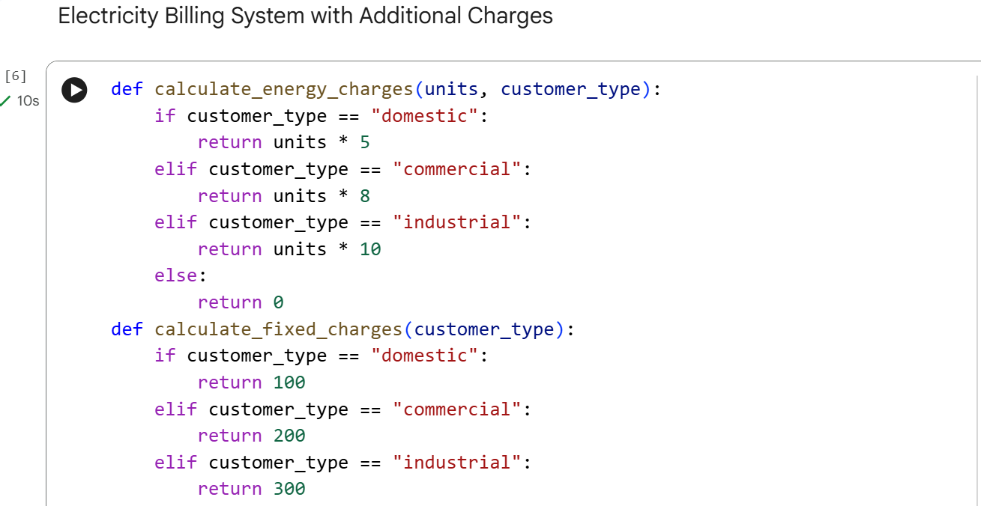
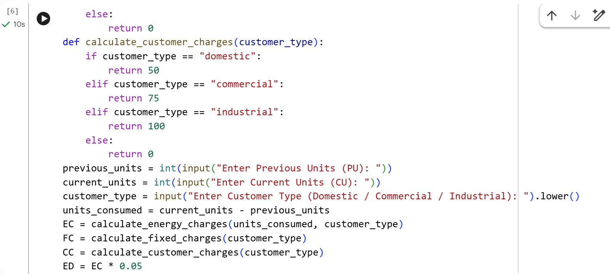
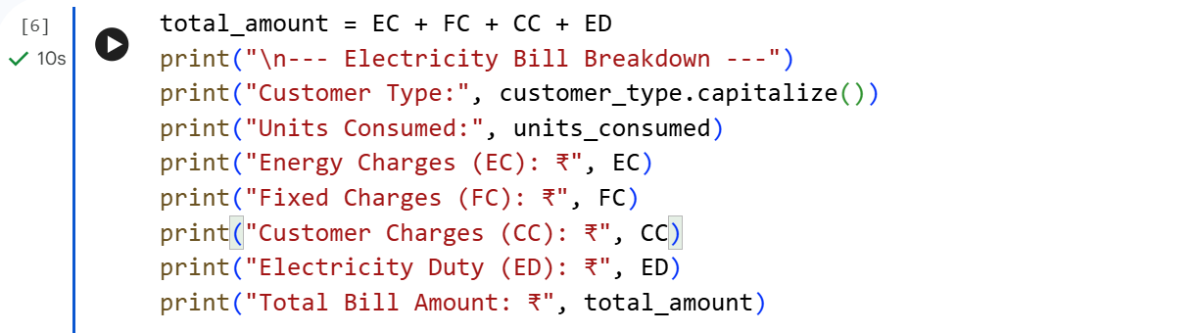
OUTPUT
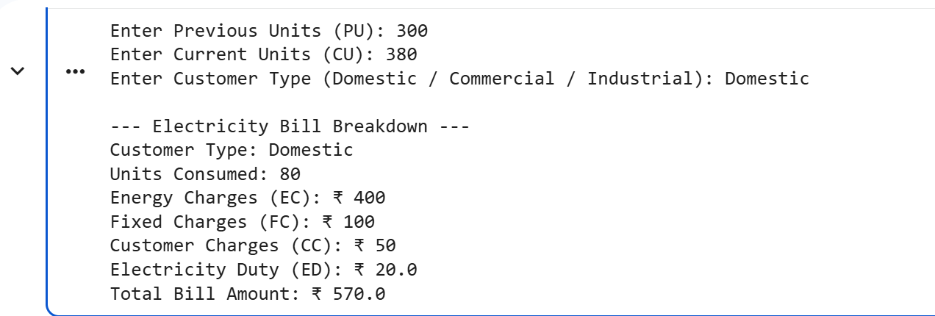
JUSTIFICATION
The program accurately computes additional electricity charges such as fixed charges, customer charges, and electricity duty to improve billing accuracy. AI assistance helped structure the calculations clearly and ensure correct percentage-based duty computation. Printing individual charge components makes the bill transparent and easy to verify. This design supports reliable and maintainable electricity billing.

TASK 5
Final Bill Generation and Output Analysis
PROMPT
Develop a complete Python electricity billing application that calculates energy charges, fixed charges, customer charges, and electricity duty. Compute the total bill as the sum of all charges and display a neatly formatted electricity bill showing each component clearly. Ensure the program is accurate, readable, and applicable to real-world billing systems.
CODE
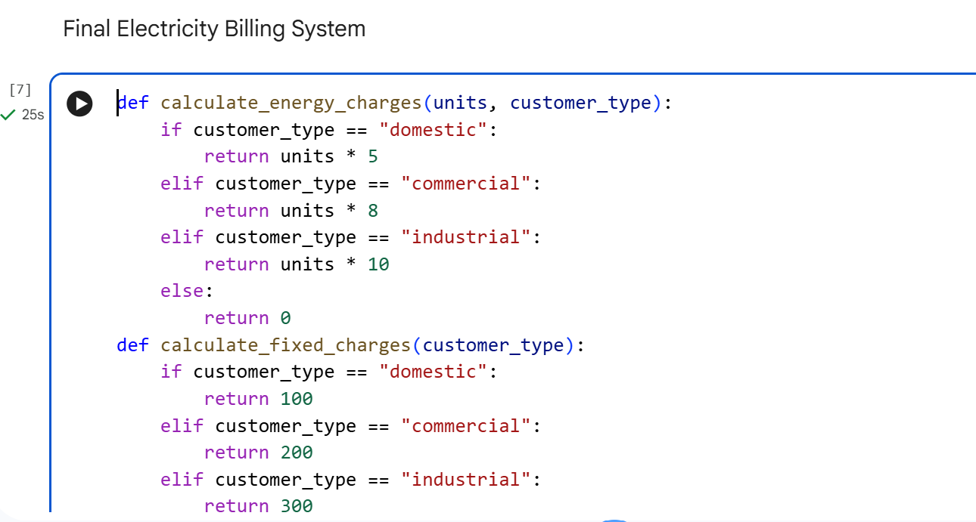
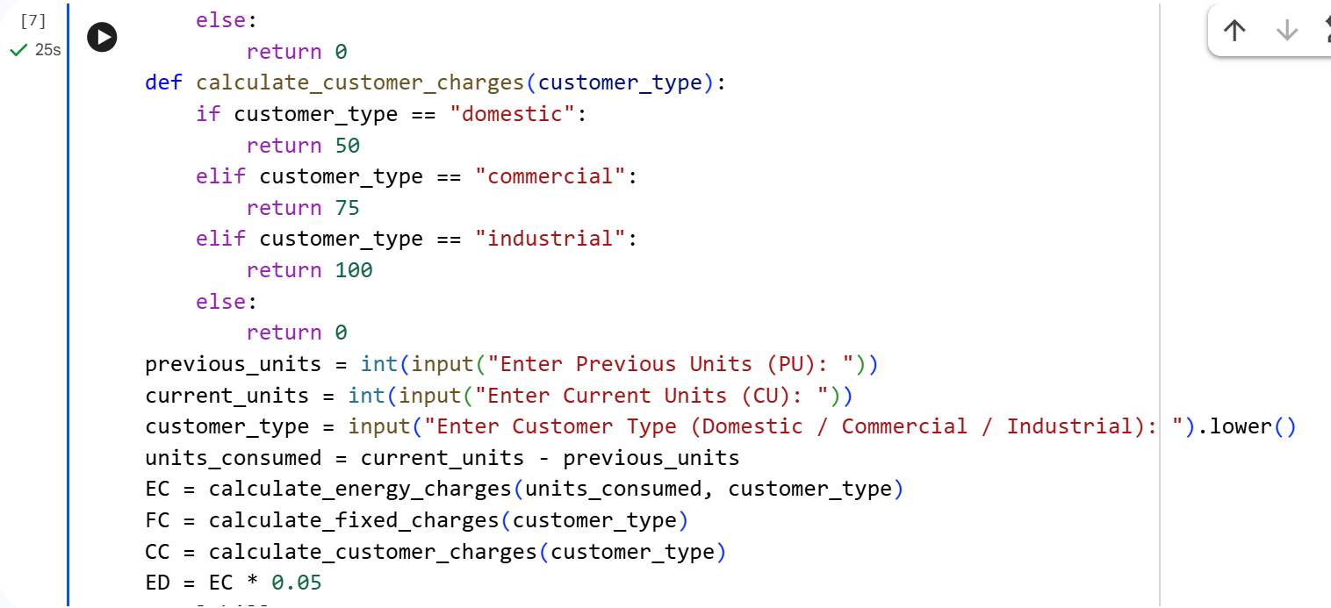
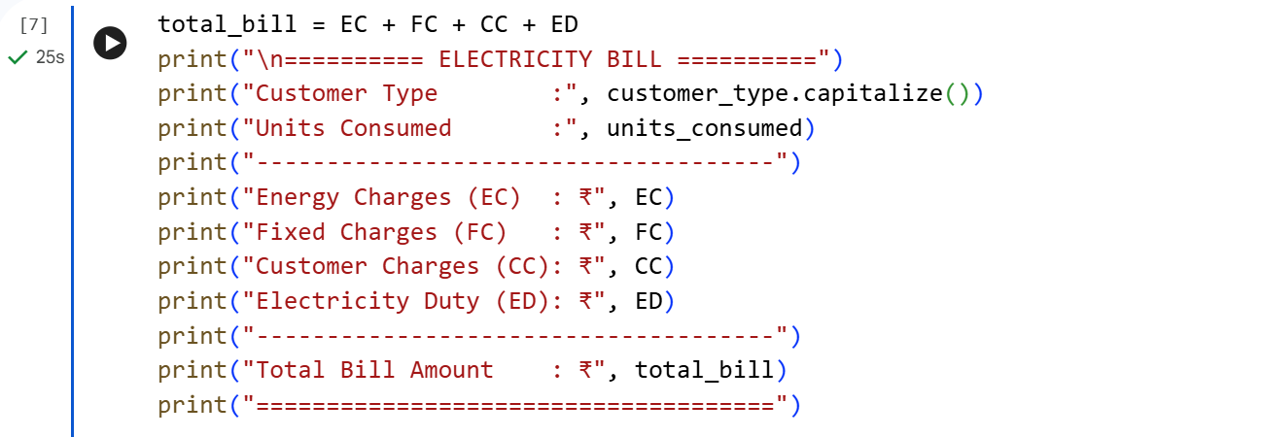
OUTPUT
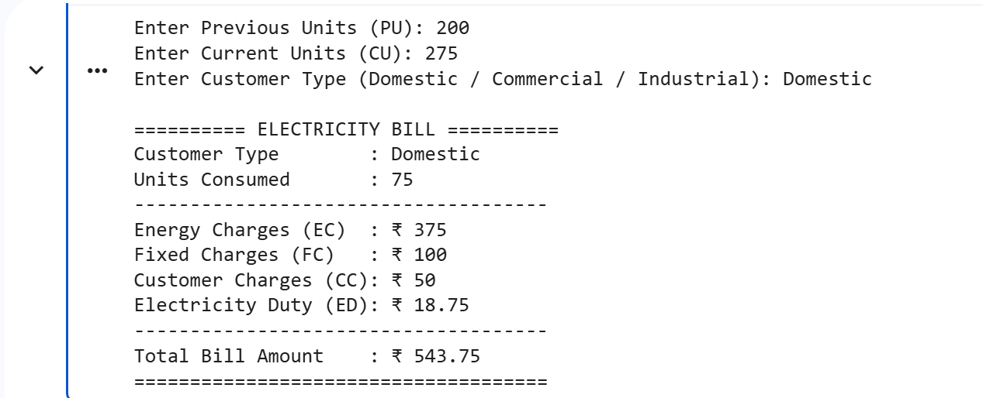
JUSTIFICATION
The program accurately computes all components of an electricity bill and presents them in a clear, structured format. AI assistance helped improve readability through modular design and clean output formatting. The logic reflects real-world electricity billing practices, ensuring practical applicability. Overall, the program is easy to understand, verify, and maintain.

